Skewness and Kurtosis

Skewness:

Skewness is the degree of asymmetry in the distribution. In simpler terms, it indicates whether the data is concentrated more on one side of the mean than the other in a frequency distribution.

A distribution is considered skewed if it's not symmetrical. There are two main types of skewness:

1. Positive skewness: Also known as right-skewed distribution, where the tail of the distribution extends towards the higher values. This means that there are more data points on the left side of the distribution, and the distribution has a longer right tail.
2. Negative skewness: Also known as left-skewed distribution, where the tail of the distribution extends towards the lower values. This means that there are more data points on the right side of the distribution, and the distribution has a longer left tail.

Kurtosis:

[Kurtosis is a measure of the "tailedness"](https://www.bing.com/ck/a?!&&p=357a86c096dc3637JmltdHM9MTcwODM4NzIwMCZpZ3VpZD0zY2IwYjQ0MC1mYzFkLTYwOGEtMzI0MC1hNzZmZmRmYTYxODYmaW5zaWQ9NTkzNw&ptn=3&ver=2&hsh=3&fclid=3cb0b440-fc1d-608a-3240-a76ffdfa6186&psq=what+is+kurtosis&u=a1aHR0cHM6Ly9lbi53aWtpcGVkaWEub3JnL3dpa2kvS3VydG9zaXM&ntb=1) or the "peakedness" of the distribution compared to the normal distribution.

There are three main types of kurtosis:

1. Mesokurtic: A distribution with kurtosis equal to that of the normal distribution (which is 0). It has a similar level of "tailedness" or "peakedness" as the normal distribution.
2. Leptokurtic: A distribution with positive kurtosis, indicating that it has fatter tails and a sharper peak compared to the normal distribution. This means that the distribution has more extreme values (outliers) than would be expected under a normal distribution.
3. Platykurtic: A distribution with negative kurtosis, indicating that it has thinner tails and a flatter peak compared to the normal distribution. This means that the distribution has fewer extreme values (outliers) than would be expected under a normal distribution.

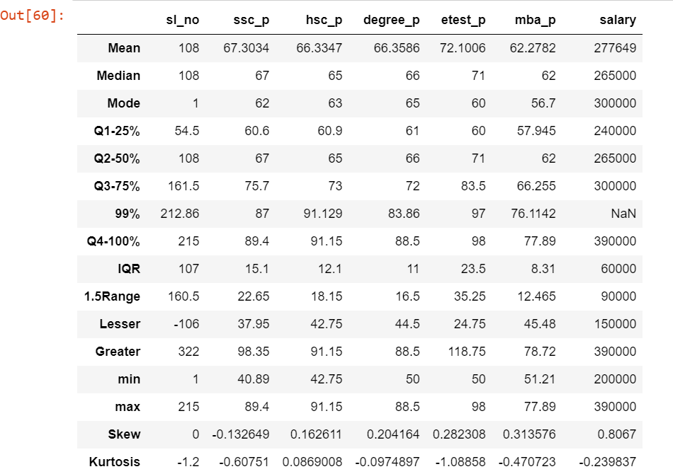

Summary:

SSC_P:

Skewness (-0.1326 negatively skewed) shows that most of the students performed well in the ssc exam and only a few scored less.

Kurtosis (-0.6075 🡪 Platykurtic (<3) ) states that the marks of most of the students are average and only few students scored well.

HSC_P:

Skewness (0.1626 positively skewed) shows that most of the students performed low in the hsc exam and only a few scored good.

Kurtosis (0.0869 🡪 Platykurtic (<3) ) states that the marks of most of the students are average and only few students scored less.

Degree_P:

Skewness (0.2041 positively skewed) shows that only few of the students performed high in the degree exam and most of the students scored less.

Kurtosis (-0.09749 🡪 Platykurtic (<3) ) states that the marks attained by most of the students in their degree exam scored average marks.

Etest_P:

Skewness (0.2823 positively skewed) means that most of the students scored less in their entrance exam and only few scored high.

Kurtosis (-1.0886 🡪 Platykurtic (<3) ) states that the students attained average marks in their entrance exam.

MBA_P:

Skewness (0.3136 positively skewed) showing the less performance of the students in their MBA exam.

Kurtosis (-1.4707 🡪 Platykurtic (<3) ) states that the students attained average marks in their entrance exam and only very few performed well.

Salary:

Skewness (0.8067 positively skewed) showing few people with high salary.

Kurtosis (-1.2398 🡪 Platykurtic (<3) ) states that only few are better performers with high salary while most others earn moderate .